**Berryessa Union School District**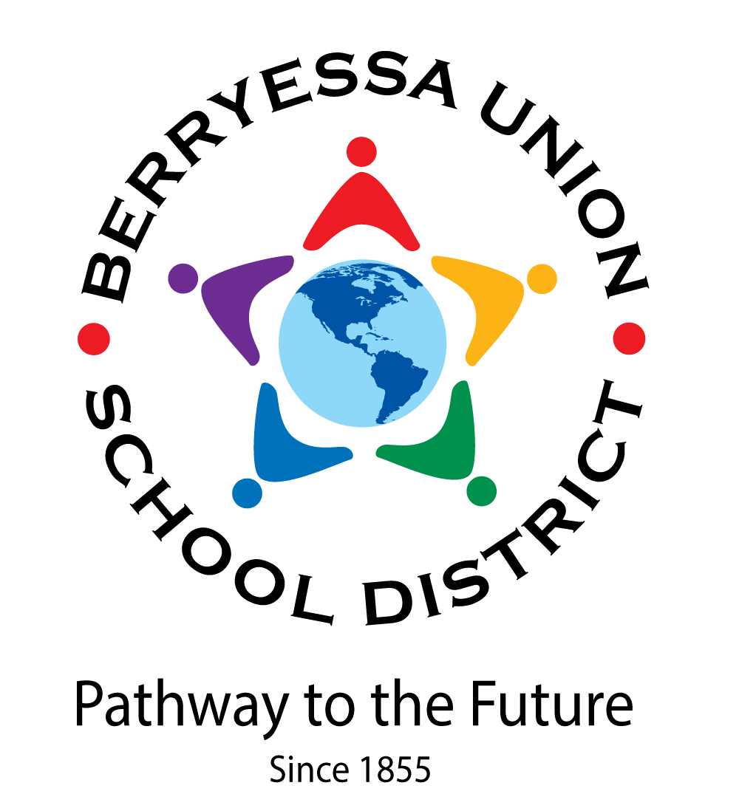

**Berryessa District Advisory Council (BDAC)**

**1376 Piedmont Road**

**San Jose, CA 95132**

**In Person - District Office Boardroom**

**October 20, 2022**

**6:00 PM**

**AGENDA**

1. Call to Order/Introductions

2. Approval of the Agenda

3. Approval of the May 26, 2022 Meeting Minutes

4. Open Agenda Items

4.1 Nomination and Election of Officers

* Chairperson
* Vice Chairperson
* Recording Secretary

4.2 SBAC Data Overview

4.3 District Declining Enrollment

4.4 COVID Testing

5. Open Discussion/Future Agenda Items

6. Future Meeting Dates 2022-2023:

* January 19, 2023 - Virtual
* March 23, 2023 - Virtual
* May 25, 2023 - In Person

7. Adjournment